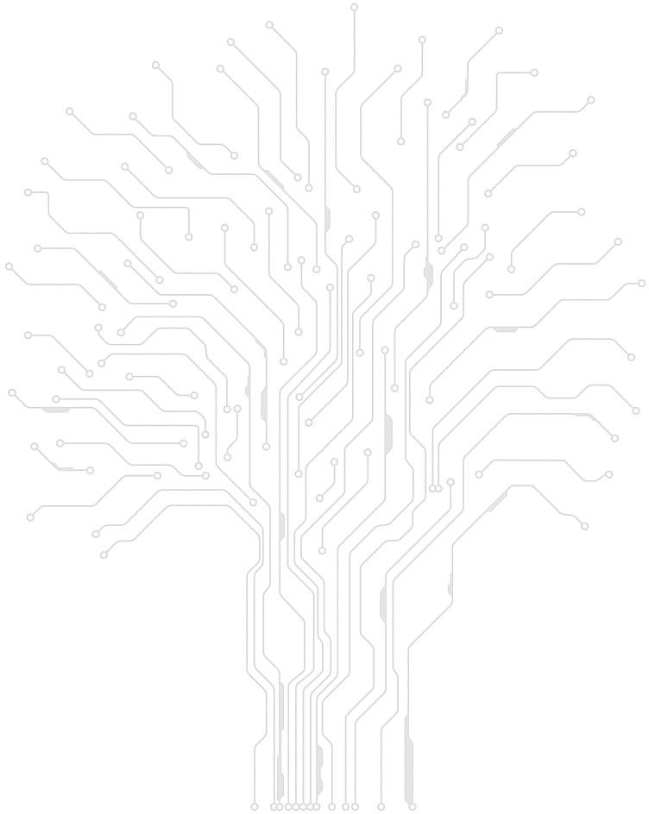

EE-232 Signals & Systems

Task 1 Report

**Group Members**

1. **Amur Saqib Pal 288334**
2. **Junaid Ali 290927**
3. **Faiez Kazi 295848**
4. **Sannan Abbasi 293786**

**Steps Performed in Task 1**

1. Time and Frequency Domain Representation of Audio Signals:

Audio signals are read using audioread() and then plotted, first in time domain and then in frequency domain through the application of Fast Fourier Transform.

1. Signals filtered through Low-Pass filter:

Next, we designed a low-pass filter of 3000Hz frequency and proceeded by passing the input signals through said filter.

1. Padded Signals

The filtered signals are then post-padded with zeroes to make sure that their vectors are eligible for the next step, namely modulation.

1. Modulating the signals with cosine function:

The padded signals are now to be multiplied by cosines of given frequencies. But first, we must declare a time interval variable for these cosines. It is worth mentioning that this variable must be 2 dimensional and transposed, so we can elementally-multiply them with our signals.

1. Summing the modulated signals:

The modulated signals from the previous steps are now simply added together and displayed.

1. Filtered the Modulated Signals and Added Signals through Band-Pass filter:

In this step, we pass the added signal through bandpass filters of different frequencies (given) to retrieve the following signals.

1. Demodulating the Signals:

Here, we simply demodulate the band-pass-filtered signals by multiplying them with their respective cosines again.

1. Filtered the Demodulated Signals through Low-Pass filter:

Lastly, the demodulated signals are passed through a low-pass filter to retrieve the original signals.

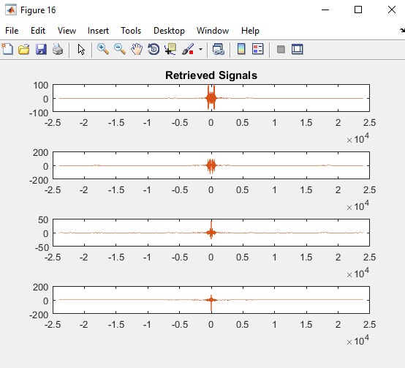

**Division of Work:**

Task 1 of the project was completed by Amur and Sannan. Both worked together in compiling and formatting the code. They both were responsible for completing the Task 1 report as well.

**Code**

Source

clc

clear all

cd 'C:\Users\ALTAMASH.2712080\Desktop\abc';

% *******************************Audio Signals fed into matlab************************************************************************************************************************

[sig1,fs1] = audioread('C:\Users\ALTAMASH.2712080\Desktop\abc\amur.m4a');

[sig2,fs2] = audioread('C:\Users\ALTAMASH.2712080\Desktop\abc\sannan.mp4');

[sig3,fs3] = audioread('C:\Users\ALTAMASH.2712080\Desktop\abc\junaid.m4a');

[sig4,fs4] = audioread('C:\Users\ALTAMASH.2712080\Desktop\abc\faiez.m4a');

% *******************************Converting Signals into Frequency Domain*************************

[sig1_freq, L1] = freqDom(sig1,fs1);

[sig2_freq, L2] = freqDom(sig2,fs2);

[sig3_freq, L3] = freqDom(sig3,fs3);

[sig4_freq, L4] = freqDom(sig4,fs4);

% *******************************Plotting of Signals in Freq and Time Domains*******************

plotSignals(sig1,sig2,sig3,sig4,L1,L2,L3,L4,'Original Signals in Time. Dom');

plotSignals(sig1_freq,sig2_freq,sig3_freq,sig4_freq,L1,L2,L3,L4,'Original Signals in Freq Dom');

% *******************************Calling the Low Pass filter function*****************************

LPF = filter2();

% *******************************Filtering the Audion Signals************************************

sig1_filtered = filter(LPF,sig1);

sig2_filtered = filter(LPF,sig2);

sig3_filtered = filter(LPF,sig3);

sig4_filtered = filter(LPF,sig4);

% *******************************Converting the Filtered Signals into freq domain******************

[sig1_freq, L1] = freqDom(sig1_filtered,fs1);

[sig2_freq, L2] = freqDom(sig2_filtered,fs2);

[sig3_freq, L3] = freqDom(sig3_filtered,fs3);

[sig4_freq, L4] = freqDom(sig4_filtered,fs4);

% *******************************Plotting of Filtered Signals in freq domain************************************

plotSignals(sig1_freq,sig2_freq,sig3_freq,sig4_freq,L1,L2,L3,L4,'Low-pass Filtered Signals');

% *******************************Finding the largest signal**********************************

S1 = length(sig1_filtered);

S2 = length(sig2_filtered);

S3 = length(sig3_filtered);

S4 = length(sig4_filtered);

Lmax = max([S1, S2, S3, S4]);

% *******************************Padding the Filtered Signals*********************************

sig1_padded = padarray(sig1_filtered, Lmax-S1, 0, 'post');

sig2_padded = padarray(sig2_filtered, Lmax-S2, 0, 'post');

sig3_padded = padarray(sig3_filtered, Lmax-S3, 0, 'post');

sig4_padded = padarray(sig4_filtered, Lmax-S4, 0, 'post');

[temp, LmaxVec] = freqDom(sig1_padded, fs1); %getting a vector for Lmax

% *******************************Converting the Padded Signals into freq domain******************

[sig1_freq, L1] = freqDom(sig1_padded,fs1);

[sig2_freq, L2] = freqDom(sig2_padded,fs2);

[sig3_freq, L3] = freqDom(sig3_padded,fs3);

[sig4_freq, L4] = freqDom(sig4_padded,fs4);

% *******************************Plotting the Padded Signals in freq domain*****************

plotSignals(sig1_freq,sig2_freq,sig3_freq,sig4_freq,LmaxVec,LmaxVec,LmaxVec,LmaxVec,'Padded Signals');

% *******************************Taking transpose so that matrices are ready for elemental multiplication********************************************************************

t1 = transpose([linspace(0,Lmax/fs1,Lmax) ; linspace(0,Lmax/fs1,Lmax)]);

t2 = transpose([linspace(0,Lmax/fs2,Lmax) ; linspace(0,Lmax/fs2,Lmax)]);

t3 = transpose([linspace(0,Lmax/fs3,Lmax) ; linspace(0,Lmax/fs3,Lmax)]);

t4 = transpose([linspace(0,Lmax/fs4,Lmax) ; linspace(0,Lmax/fs4,Lmax)]);

% *******************************Modulating the Signals with cosine of assigned frequencies**********************************

fm1 = 3000;

fm2 = 9000;

fm3 = 15000;

fm4 = 21000;

mod1 = cos(2*pi*fm1*t1);

mod2 = cos(2*pi*fm2*t2);

mod3 = cos(2*pi*fm3*t3);

mod4 = cos(2*pi*fm4*t4);

modded1 = sig1_padded.*mod1;

modded2 = sig2_padded.*mod2;

modded3 = sig3_padded.*mod3;

modded4 = sig4_padded.*mod4;

% *******************************Converting Modulated Signals into freq domain*******************************

[sig1_freq, L1] = freqDom(modded1,fs1);

[sig2_freq, L2] = freqDom(modded2,fs2);

[sig3_freq, L3] = freqDom(modded3,fs3);

[sig4_freq, L4] = freqDom(modded4,fs4);

% *******************************Plotting Modulated Signals in freq domain*************************

plotSignals(sig1_freq,sig2_freq,sig3_freq,sig4_freq,L1,L2,L3,L4,'Modulated Signals');

% *******************************Adding then Converting and Plotting the Modulated Signals in freq domain*****************************

added = modded1 + modded2 + modded3 + modded4;

sig_addedfreq = freqDom(added,fs1);

figure;

plot(LmaxVec,sig_addedfreq);

title('Added Signals');

% *******************************Calling Band-Pass filter functions*******************************

BPF1 = filter3();

BPF2 = filter4();

BPF3 = filter5();

BPF4 = filter6();

% ********************************Filtering the Summed Signal through Band-Pass filter********************************************

added_filtered1 = filter(BPF1,added);

added_filtered2 = filter(BPF2,added);

added_filtered3 = filter(BPF3,added);

added_filtered4 = filter(BPF4,added);

%

% ********************************Converting the Filtered Signals into freq domain**********************************************

[sig1_freq, L1] = freqDom(added_filtered1,fs1);

[sig2_freq, L2] = freqDom(added_filtered2,fs2);

[sig3_freq, L3] = freqDom(added_filtered3,fs3);

[sig4_freq, L4] = freqDom(added_filtered4,fs4);

% ********************************Plotting Filtered Signals in freq domain*******************************************************

plotSignals(sig1_freq,sig2_freq,sig3_freq,sig4_freq,L1,L2,L3,L4,'Summed & Band-passed Signals');

% ********************************Demodulating the Signals************************************************************************

demodded1 = added_filtered1.*mod1;

demodded2 = added_filtered2.*mod2;

demodded3 = added_filtered3.*mod3;

demodded4 = added_filtered4.*mod4;

% ********************************Converting the Demodualted Signals in freq domain******************************************************

[sig1_freq, L1] = freqDom(demodded1,fs1);

[sig2_freq, L2] = freqDom(demodded2,fs2);

[sig3_freq, L3] = freqDom(demodded3,fs3);

[sig4_freq, L4] = freqDom(demodded4,fs4);

% ********************************Plotting Demodulated Signals in freq domain**************************************************************

plotSignals(sig1_freq,sig2_freq,sig3_freq,sig4_freq,L1,L2,L3,L4,'Demodulated Signals');

% ********************************Filtering the Demodulated Signals through low pass filter*************************************************

demoddedf1 = filter(LPF, demodded1);

demoddedf2 = filter(LPF, demodded2);

demoddedf3 = filter(LPF, demodded3);

demoddedf4 = filter(LPF, demodded4);

% ********************************Converting Filtered Signals into freq domain************************************************************

[sig1_freq, L1] = freqDom(demoddedf1,fs1);

[sig2_freq, L2] = freqDom(demoddedf2,fs2);

[sig3_freq, L3] = freqDom(demoddedf3,fs3);

[sig4_freq, L4] = freqDom(demoddedf4,fs4);

% ********************************Plotting the Filtered Signals in freq domain************************************************************

plotSignals(sig1_freq,sig2_freq,sig3_freq,sig4_freq,L1,L2,L3,L4,'Retrieved Signals');

% ********************************Playing the Finally Retrieved Audios*********************************************************************

audiowrite('C:\Users\ALTAMASH.2712080\Desktop\abc\amurRegen.m4a',demoddedf1,fs1);

audiowrite('C:\Users\ALTAMASH.2712080\Desktop\abc\sannanRegen.mp4',demoddedf2,fs2);

audiowrite('C:\Users\ALTAMASH.2712080\Desktop\abc\junaidRegen.m4a',demoddedf3,fs3);

audiowrite('C:\Users\ALTAMASH.2712080\Desktop\abc\faiezRegen.m4a',demoddedf4,fs4);

Supplementary Functions:

1. freqDom

% This function converts time domain signals into freq domain signals

function [y,n] = freqDom(sig,fs)

L = length(sig);

y = fft(sig,L);

y = fftshift(y);

n = ((-L/2:L/2-1)*(fs/L));

end

1. plotSignals

function [] = plotSignals(y1,y2,y3,y4,L1,L2,L3,L4,titleStr)

figure;

subplot(411);

plot(L1,y1);

title(titleStr);

subplot(412);

plot(L2,y2);

subplot(413);

plot(L3,y3);

subplot(414);

plot(L4,y4);

end

1. filter1

function Hd = filter1

%FILTER1 Returns a discrete-time filter object.

% MATLAB Code

% Generated by MATLAB(R) 9.2 and the DSP System Toolbox 9.4.

% Generated on: 20-May-2021 20:51:26

% Equiripple Lowpass filter designed using the FIRPM function.

% All frequency values are in Hz.

Fs = 48000; % Sampling Frequency

N = 10; % Order

Fpass = 0; % Passband Frequency

Fstop = 3000; % Stopband Frequency

Wpass = 1; % Passband Weight

Wstop = 1; % Stopband Weight

dens = 20; % Density Factor

% Calculate the coefficients using the FIRPM function.

b = firpm(N, [0 Fpass Fstop Fs/2]/(Fs/2), [1 1 0 0], [Wpass Wstop], ...

{dens});

Hd = dfilt.dffir(b);

% [EOF]

1. filter2

function Hd = filter2

%FILTER2 Returns a discrete-time filter object.

% MATLAB Code

% Generated by MATLAB(R) 9.2 and the Signal Processing Toolbox 7.4.

% Generated on: 21-May-2021 17:57:04

% Equiripple Lowpass filter designed using the FIRPM function.

% All frequency values are in Hz.

Fs = 48000; % Sampling Frequency

Fpass = 2900; % Passband Frequency

Fstop = 3020; % Stopband Frequency

Dpass = 0.057501127785; % Passband Ripple

Dstop = 0.0001; % Stopband Attenuation

dens = 20; % Density Factor

% Calculate the order from the parameters using FIRPMORD.

[N, Fo, Ao, W] = firpmord([Fpass, Fstop]/(Fs/2), [1 0], [Dpass, Dstop]);

% Calculate the coefficients using the FIRPM function.

b = firpm(N, Fo, Ao, W, {dens});

Hd = dfilt.dffir(b);

% [EOF]

1. filter3

function Hd = filter3

%FILTER3 Returns a discrete-time filter object.

% MATLAB Code

% Generated by MATLAB(R) 9.2 and the Signal Processing Toolbox 7.4.

% Generated on: 25-May-2021 13:10:25

% Equiripple Bandpass filter designed using the FIRPM function.

% All frequency values are in Hz.

Fs = 48000; % Sampling Frequency

Fstop1 = 2000; % First Stopband Frequency

Fpass1 = 2500; % First Passband Frequency

Fpass2 = 3500; % Second Passband Frequency

Fstop2 = 4000; % Second Stopband Frequency

Dstop1 = 0.001; % First Stopband Attenuation

Dpass = 0.057501127785; % Passband Ripple

Dstop2 = 0.001; % Second Stopband Attenuation

dens = 20; % Density Factor

% Calculate the order from the parameters using FIRPMORD.

[N, Fo, Ao, W] = firpmord([Fstop1 Fpass1 Fpass2 Fstop2]/(Fs/2), [0 1 ...

0], [Dstop1 Dpass Dstop2]);

% Calculate the coefficients using the FIRPM function.

b = firpm(N, Fo, Ao, W, {dens});

Hd = dfilt.dffir(b);

% [EOF]

1. filter4

function Hd = filter4

%FILTER4 Returns a discrete-time filter object.

% MATLAB Code

% Generated by MATLAB(R) 9.2 and the Signal Processing Toolbox 7.4.

% Generated on: 25-May-2021 15:08:58

% Equiripple Bandpass filter designed using the FIRPM function.

% All frequency values are in Hz.

Fs = 48000; % Sampling Frequency

Fstop1 = 8000; % First Stopband Frequency

Fpass1 = 8500; % First Passband Frequency

Fpass2 = 9500; % Second Passband Frequency

Fstop2 = 10000; % Second Stopband Frequency

Dstop1 = 0.001; % First Stopband Attenuation

Dpass = 0.057501127785; % Passband Ripple

Dstop2 = 0.001; % Second Stopband Attenuation

dens = 20; % Density Factor

% Calculate the order from the parameters using FIRPMORD.

[N, Fo, Ao, W] = firpmord([Fstop1 Fpass1 Fpass2 Fstop2]/(Fs/2), [0 1 ...

0], [Dstop1 Dpass Dstop2]);

% Calculate the coefficients using the FIRPM function.

b = firpm(N, Fo, Ao, W, {dens});

Hd = dfilt.dffir(b);

% [EOF]

1. filter5

function Hd = filter5

%FILTER5 Returns a discrete-time filter object.

% MATLAB Code

% Generated by MATLAB(R) 9.2 and the Signal Processing Toolbox 7.4.

% Generated on: 25-May-2021 15:13:52

% Equiripple Bandpass filter designed using the FIRPM function.

% All frequency values are in Hz.

Fs = 48000; % Sampling Frequency

Fstop1 = 14000; % First Stopband Frequency

Fpass1 = 14500; % First Passband Frequency

Fpass2 = 15500; % Second Passband Frequency

Fstop2 = 16000; % Second Stopband Frequency

Dstop1 = 0.001; % First Stopband Attenuation

Dpass = 0.057501127785; % Passband Ripple

Dstop2 = 0.001; % Second Stopband Attenuation

dens = 20; % Density Factor

% Calculate the order from the parameters using FIRPMORD.

[N, Fo, Ao, W] = firpmord([Fstop1 Fpass1 Fpass2 Fstop2]/(Fs/2), [0 1 ...

0], [Dstop1 Dpass Dstop2]);

% Calculate the coefficients using the FIRPM function.

b = firpm(N, Fo, Ao, W, {dens});

Hd = dfilt.dffir(b);

% [EOF]

1. filter6

function Hd = filter6

%FILTER6 Returns a discrete-time filter object.

% MATLAB Code

% Generated by MATLAB(R) 9.2 and the Signal Processing Toolbox 7.4.

% Generated on: 25-May-2021 15:14:39

% Equiripple Bandpass filter designed using the FIRPM function.

% All frequency values are in Hz.

Fs = 48000; % Sampling Frequency

Fstop1 = 20000; % First Stopband Frequency

Fpass1 = 20500; % First Passband Frequency

Fpass2 = 21500; % Second Passband Frequency

Fstop2 = 22000; % Second Stopband Frequency

Dstop1 = 0.001; % First Stopband Attenuation

Dpass = 0.057501127785; % Passband Ripple

Dstop2 = 0.001; % Second Stopband Attenuation

dens = 20; % Density Factor

% Calculate the order from the parameters using FIRPMORD.

[N, Fo, Ao, W] = firpmord([Fstop1 Fpass1 Fpass2 Fstop2]/(Fs/2), [0 1 ...

0], [Dstop1 Dpass Dstop2]);

% Calculate the coefficients using the FIRPM function.

b = firpm(N, Fo, Ao, W, {dens});

Hd = dfilt.dffir(b);

% [EOF]